|  |
| --- |
| **Facilitator Name: Pam Kobryn; Participants: Fred Gillenwater (Tenet3); Maggie Johnson-Pint (Istari Digital); Rob Love (General Atomics); Tom Marler (Booz Allen Hamilton); Stephanie Sprinkle (UDRI); Jason York (General Electric)** |
| Table Topic: How to Present a Meaningful Model and Submit It as a Deliverable for a SETR (Model Based Decision Making for Leadership) |
| 1. Meaningful Model and submitting them as deliverables for a SETR- model based decision making for leaders. 2. What attributes or characteristics of system model are necessary to make the model a meaningful SETR deliverable to stakeholders (e.g. PMs, ENs, LOGs, Cyber, T&E, Users, Senior Material Leaders, Program Executive Officers)? 3. What techniques can be used to deliver, present and interact with the model before, during or after a SETR event?   **GENERAL ATTRIBUTES AND CHARACTERISTICS OF SYSTEM MODELS  AS DELVERABLES FOR SETR AND MODEL-BASED DECISION MAKING:**   * The model should convey a story that has meaning in the context of the SETR so that stakeholders don’t have to guess or do a lot of homework to participate in the SETR * The model should include multiple levels of abstraction to make it easy for a stakeholder to navigate from the top-level descriptions of the operational need, the program, and the system down into the nitty-gritty details (e.g., from 30K ft PM view down to geometry, individual test points, etc., SME views; from entry/exit criteria down to evidence) * The model should be truthful, current, consistent, and complete at the time of review so that everyone is working from the same snapshot in time for the review and is able to see what has changed since the last snapshot (and/or last review) * The model should be a ‘lifecycle model’ which persists and adapts over time and should  (a) capture and maintain snapshots in time, (b) include versioning, and (c) allow branching to support (i) tracing back through time, (ii) recovery from choices that don’t pan out, and (iii) consideration of multiple options in parallel * The model should capture an ‘Intersubjective Source of Truth’ built on a common language understood by all stakeholders * The model should be flexibly expressive to allow for the inclusion of domain-specific data relevant to each stakeholder so that different stakeholder groups aren’t forced to align on all of the same expressions and schema or to maintain pre-selected data expressions and schema for the entire lifecycle * The model should be parsable, interrogable, and accessible in a manner that supports searches, visualizations, analyses, and use/reuse of model components by stakeholders in the digital environments and with the tools to which they have access * The model should integrate with an API ecosystem such that changes to the model can be pushed via software, changes can be published to alert subscribers, and stakeholders can create custom visualizations and dashboards that stay updated without needing to download the latest version of the model   **SPECIFIC ATTRIBUTES AND CHARACTERISTICS OF SYSTEM MODELS  AS DELVERABLES FOR SETR AND MODEL-BASED DECISION MAKING:**   * PM: WBS, cost, schedule, risk – all linked and traceable to burndown forecasts and data and associated execution-level details * EN: Modeled down to physics level; captures the failure scenarios and modes and how they were/are explored; captures all variables/parameters used in simulations and analyses (including those pertaining to the environment); includes all permutations of the models, simulations, and analyses * LG: sustainment-based digital twin with lifing capability for predictive maintenance * Cyber: network attack surface; fallback systems for connectivity loss; exposed/open ports and comms protocols * T&E: Model linked from requirements to V&V plans to test results; model proves all requirements are covered in the V&V plan and by the test results * End Users/Operators: Model traces from critical mission capabilities to how they are delivered by the system design; model traces from safety/airworthiness requirements to how they are satisfied by the system design * Senior Material Leaders (SML): Intent of the program is clearly discernable for those not deeply familiar with it * Program Executive Officers: Same as PM and SML   **TECHNIQUES TO DELIVER, PRESENT, AND INTERACT WITH THE MODEL**  **ANYTIME:**   * Enable, encourage, and enforce use of the model * Lifecyle management applied to the model (model lifecycle management ecosystem; config management and control, versioning, etc.) * Flexible access controls to support all stakeholders with dynamic redaction * Intuitively navigable user interface for the model * Structured and/or machine-readable database backend * Dashboards via API queries to database * Tied to entry and exit criteria * Ledger of approvals * Visualizations for ‘diffs’ and ‘change sets’ * Automated consistency checks   **BEFORE SETR EVENT:**   * Run consistency validations, release formally approved artifacts, validate closure of action items, publish data to dashboards * Precomposed viewpoints that outline what is to be reviewed in the SETR, navigable to the supporting details * Precomposed model-based checklist of what needs to be answered/reviewed/approved and by whom to close out the SETR * Summary status dashboard for entry/exit criteria fulfillment * Summary status dashboard of requirements-to-test-scenario status * Lower-level summary dashboards for Pre-SETR events   **DURING SETR EVENT:**   * Navigate from precomposed viewpoints, dashboards, and checklists * Interrogate the locked model and data and run automated checks as necessary to report status, demonstrate ‘how met’, and answer questions * Collect comments and track decisions/approvals with attribution in the model and/or in model-based checklists or comment matrices   **AFTER SETR EVENT**:   * Digitally sign and archive the as-reviewed model and associated database, including all attributed comments, decisions, and approvals * Issue and track action items and update and re-release model and database as necessary |

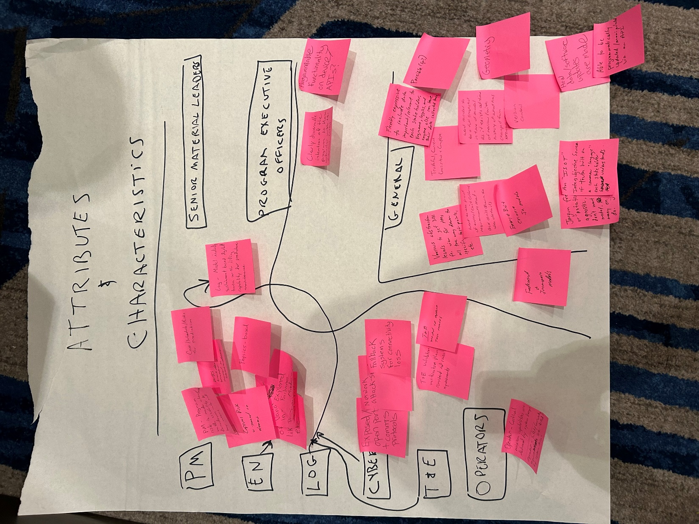

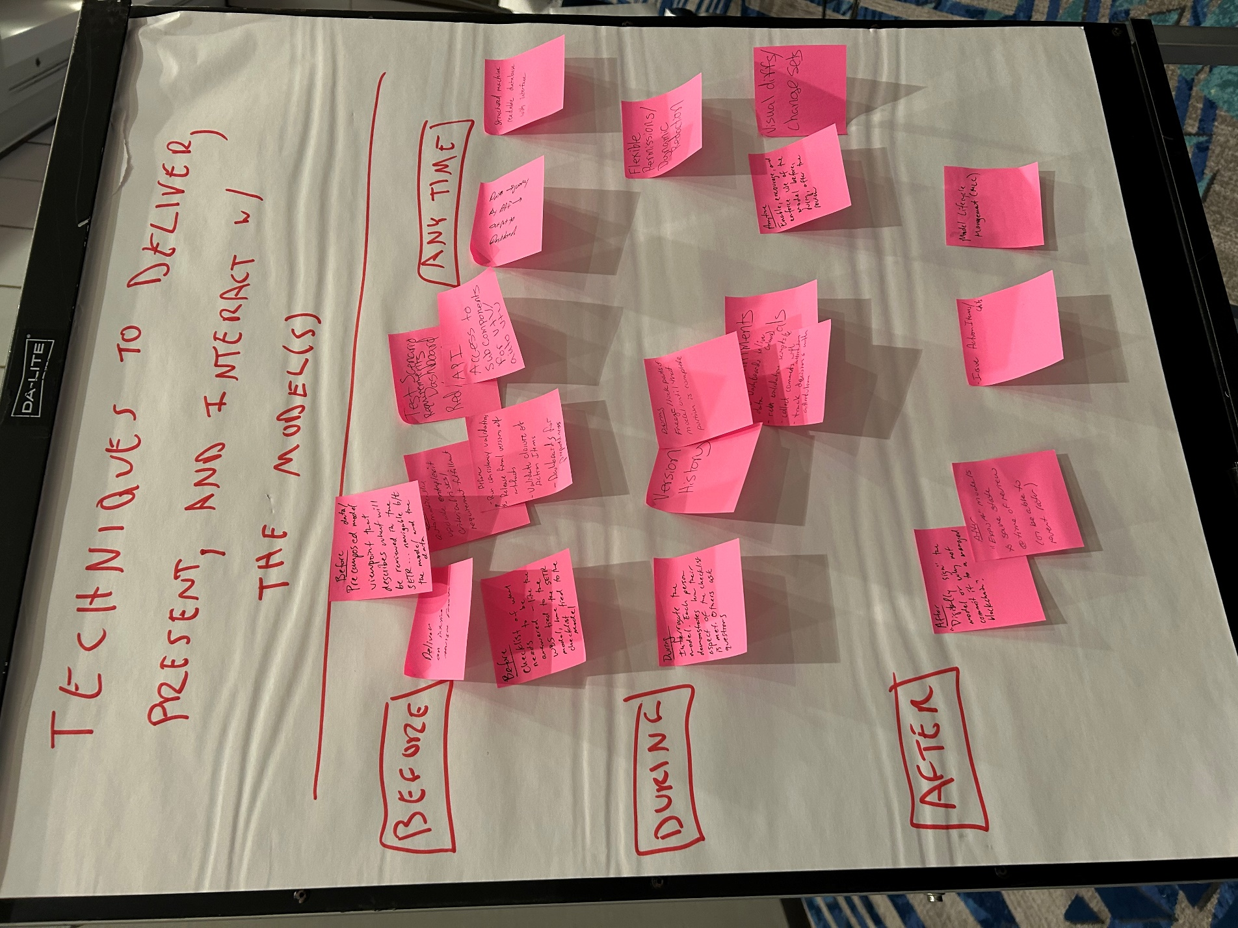

**BONUS ROUND: WHAT DID NIPRGPT SAY?**

**User Prompt:**

*What attributes or characteristics of a system model are necessary to make the model a meaningful systems engineering technical review deliverable to stakeholders in the roles of program manager, engineer, logistics specialist, cyber resiliency expert, test and evaluation expert, system operator, Senior Material Leader, and Program Executive Officer?*

**NIPRGPT Response:**

To make a system model a meaningful Systems Engineering (SE) technical review deliverable to stakeholders, the following attributes or characteristics are necessary:

1. **Clear and Concise Documentation**: The model should be well-documented, with clear and concise descriptions of the system's architecture, components, interfaces, and behaviors. This will enable stakeholders to quickly understand the system's design and functionality.
2. **Multi-Disciplinary Views**: The model should provide multiple views of the system, catering to the diverse needs of stakeholders. For example:
   * Program managers: cost, schedule, and performance views
   * Engineers: detailed design and technical views
   * Logistics specialists: maintenance, support, and sustainment views
   * Cyber resiliency experts: security and vulnerability views
   * Test and evaluation experts: testing and validation views
   * System operators: operational and user interface views
3. **Scalability and Flexibility**: The model should be scalable and flexible enough to accommodate changing system requirements, design iterations, and evolving stakeholder needs.
4. **Standardization and Interoperability**: The model should adhere to industry standards (e.g., SysML, UML, DoDAF) and be interoperable with other models and tools, ensuring seamless communication and data exchange among stakeholders.
5. **Analytical and Simulation Capabilities**: The model should support analytical and simulation-based analyses, enabling stakeholders to evaluate system performance, identify potential issues, and optimize system design.
6. **Data-Driven Insights**: The model should be data-driven, incorporating relevant data and metrics to support informed decision-making. This may include data on system performance, reliability, maintainability, and other key parameters.
7. **Stakeholder-Accessible**: The model should be accessible to stakeholders with varying levels of technical expertise, using intuitive interfaces and visualization tools to facilitate understanding and communication.
8. **Traceability and Verification**: The model should provide traceability to system requirements, design constraints, and testing and evaluation results, ensuring that the system design is verifiable and compliant with stakeholder expectations.
9. **Collaboration and Communication**: The model should facilitate collaboration and communication among stakeholders, enabling them to share information, discuss design trade-offs, and make informed decisions.
10. **Configurable and Adaptable**: The model should be configurable and adaptable to accommodate changing system requirements, new technologies, and evolving stakeholder needs, ensuring that the system design remains relevant and effective throughout its lifecycle.

To ensure that the system model meets these attributes, it's essential to involve stakeholders from various disciplines and roles throughout the model's development and refinement. This will help ensure that the model is meaningful, useful, and effective in supporting Systems Engineering technical reviews and stakeholder decision-making.

For the specific roles mentioned, the following additional considerations may be relevant:

* **Program Manager**: The model should provide insights into system cost, schedule, and performance, as well as risks and opportunities for improvement.
* **Engineer**: The model should provide detailed technical information, such as system architecture, component design, and interface definitions.
* **Logistics Specialist**: The model should provide information on system maintenance, support, and sustainment, including spare parts, supply chain, and maintenance procedures.
* **Cyber Resiliency Expert**: The model should provide insights into system security and vulnerability, including threat assessments, risk mitigation strategies, and security controls.
* **Test and Evaluation Expert**: The model should provide information on system testing and evaluation, including test plans, test cases, and test results.
* **System Operator**: The model should provide information on system operation, including user interfaces, operating procedures, and system performance metrics.
* **Senior Material Leader**: The model should provide insights into system material acquisition, procurement, and management, including supply chain risks and opportunities.
* **Program Executive Officer**: The model should provide a comprehensive overview of the system, including its technical, schedule, and cost performance, as well as risks and opportunities for improvement.

**User Prompt:**

*What techniques can be used to deliver, present, and interact with a model before, during, or after a systems engineering technical review event?*

**NIPRGPT Response:**

To deliver, present, and interact with a model before, during, or after a Systems Engineering (SE) technical review event, the following techniques can be used:

**Pre-Review Techniques**

1. **Model-based reports and documents**: Generate reports and documents from the model, such as system design descriptions, interface control documents, and test plans.
2. **Model-based briefings**: Provide briefings and presentations that use the model to explain system concepts, designs, and trade-offs.
3. **Model-based training**: Offer training sessions that use the model to educate stakeholders on system operations, maintenance, and troubleshooting.
4. **Model-based webinars**: Host webinars that demonstrate the model and its capabilities, allowing stakeholders to ask questions and provide feedback.

**Presentation Techniques**

1. **Interactive model demonstrations**: Use interactive tools, such as modeling and simulation software, to demonstrate system behavior and performance.
2. **3D visualization**: Utilize 3D visualization tools to showcase system architecture, components, and interfaces.
3. **Model-based storytelling**: Use narrative techniques to explain system concepts, design decisions, and trade-offs, making the model more accessible and engaging.
4. **Collaborative model review**: Facilitate collaborative review sessions, where stakeholders can interact with the model, ask questions, and provide feedback.

**Interactive Techniques**

1. **Model-based what-if analysis**: Use the model to perform what-if analyses, exploring the impact of different design decisions or scenarios on system performance.
2. **Model-based trade studies**: Conduct trade studies using the model, evaluating the pros and cons of different design options or technologies.
3. **Model-based sensitivity analysis**: Perform sensitivity analyses to understand how system performance is affected by changes in input parameters or assumptions.
4. **Model-based feedback and critique**: Encourage stakeholders to provide feedback and critique on the model, using this input to refine and improve the model.

**Post-Review Techniques**

1. **Model-based action item tracking**: Use the model to track action items, decisions, and open issues from the review, ensuring that they are addressed and resolved.
2. **Model-based lesson learned documentation**: Document lessons learned from the review, using the model to capture best practices, challenges, and areas for improvement.
3. **Model-based knowledge management**: Use the model to manage knowledge and information from the review, making it accessible to stakeholders and future review teams.
4. **Model-based review close-out report**: Generate a close-out report from the model, summarizing the review findings, recommendations, and outcomes.

**Tools and Technologies**

1. **Modeling and simulation software**: Utilize tools like SysML, UML, or simulation software to create and interact with the model.
2. **Collaboration platforms**: Leverage collaboration platforms, such as web conferencing tools or online workspaces, to facilitate model-based interaction and review.
3. **Virtual and augmented reality**: Use virtual and augmented reality technologies to create immersive, interactive model experiences.
4. **Data analytics and visualization**: Apply data analytics and visualization techniques to extract insights from the model and present them in a clear, concise manner.

By using these techniques, you can effectively deliver, present, and interact with a model before, during, or after a Systems Engineering technical review event, ensuring that stakeholders are engaged, informed, and empowered to make informed decisions.